Working logs

# Time Series Prediction with AI Methods for Fluid Flow

Tianyi Zhao

Time Series Prediction with AI Methods for Fluid Flow 1

June 2 2

Archives 2

June 9 2

Archives 2

June 16 2

Archives 2

June 23 2

Archives 2

June 30 3

Archives 3

July 7 3

Archives 3

July 14 3

Archives 3

July 21 5

Archives 5

July 28 5

Archives 5

Aug 4 6

Archives 6

Aug 11 6

Archives 6

Aug 18 6

Archives 6

Aug 25 6

Archives 6

# June 2

### Archives

1. GAN, from paper and books and some tutorials. Theory, application scenarios, what do we need to pay attention to when training
2. Get the basic idea of how to use GAN to predicting time series

(The reviews are included in project plan)

# June 9

### Archives

1. Prototype MLP to predict next time level given the current time level with COVID data.
2. Understanding the time stepping procedure in paper ‘Machine learning for fast and reliable solution of time-dependent differential equations’.

(The reviews are included in project plan)

# June 16

### Archives

1. Understand ROM and POD by talk given by Claire.
2. Prototype POD-MLP with old FPC data.
3. Prototype POD-MLP-deriv with old FPC data.

Lose amplitude, why?

Comment from Chris:

Zhao, Tianyi Impressive - thanks. You need more epochs and need to visualize the FPC results using paraview. Great you will be repeating these two methods with GAN this week. You could try the slug flow problem also rather than FPC. After that repeat both MLP and GAN using domain decomposition methods for FPC. Post your task list for the coming week.

# June 23

### Archives

1. Write the project plan.
2. Visualize the FPC results.

Comment from Claire:

[Wednesday 03:13] Heaney, Claire E

Hi Tianyi, Sorry for not getting back to you sooner. Thanks for your update. The 5 dimensions that you spoke about in your video are the 5 POD coefficients. Did you try with smaller batch sizes? When you are plotting the loss against the number of epochs could you use a logscale on the y axis - this will show better how the loss decays. Really good results, with the derivative MLP performing better than the standard MLP. It doesn't surprise me that the model did not predict very far into the future before losing amplitude. We've seen this happen before.

I think over the next week, perhaps you could try

(1) can you plot the final results in high-dimensional space and compare with the original CFD results

(2) having the option to subtract out the mean of the snapshots before applying POD - you will have to save this mean (you can save it to vtu) and add it to get the final results

(3) can you try training with less data (nTrain=500, nTest=100) just to see if it works less well or not - or perhaps plot a learning curve (some examples here <https://scikit-learn.org/stable/auto_examples/model_selection/plot_learning_curve.html>)

(4) can you do a hyperparameter optimsation (ie try out relu, tanh, and some different architectures 5-20-20-5, 5-50-50-5, 5-100-100-5, 5-20-5, 5-50-5) perhaps using nTrain=600, nValidation=200, nTest=200, or 800-100-100

Are you using the new flow past a cylinder data?

# June 30

### Archives

1. Training MLP with new FPC data. Try to follow Claire’s suggestions and do more training.
2. Started working on GAN with Vinicious’s GAN and corporate with Jon.

MLP training log:

1. Training set division

T=35, but the effect of MLP is not good, keep 800-100-100

Does Learning-curve need to be adjusted?

2. Batch-size and lr have been determined, and dynamic attenuation has been added to lr

Do I need to change the parameters of lr attenuation?

3. Network structure

5-100-100-5 works best.

Is it necessary to add layers to prevent overfitting? The activation function of the regression problem?

4. Training process

Epochs=5000

Add backpropagation?

5. Overfitting

Regularization, parameter adaptation, network structure

6. Results

How does the Error part appear?

Conclusion of MLP:

1. smaller batch sizes (256->32): significantly increased accuracy
2. learning rate (0.001->0.01): overfitting; 0.0001
3. Plotting Learning Curves: >50% for training set
4. NN structure (800-100-100):

|  |  |  |
| --- | --- | --- |
|  | relu | tanh |
| 5-20-20-5 | 0.048 | - terrible results |
| 5-50-50-5 | 0.013 | - |
| 5-100-100-5 | 0.007, 0.006 (overfitting?) | - |
| 5-20-5 | Test RMSE: 0.028 | - |
| 5-50-5 | Test RMSE: 0.021 | - |
| 5-100-5 | Test RMSE: 0.014 | - |

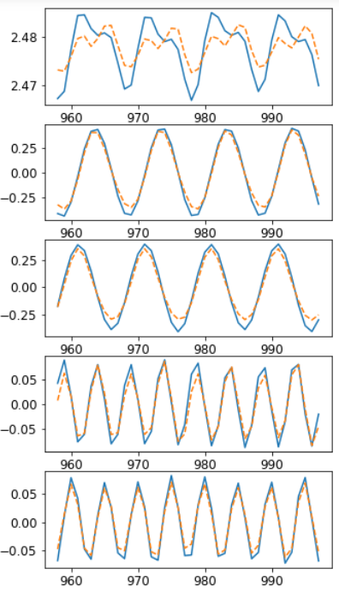 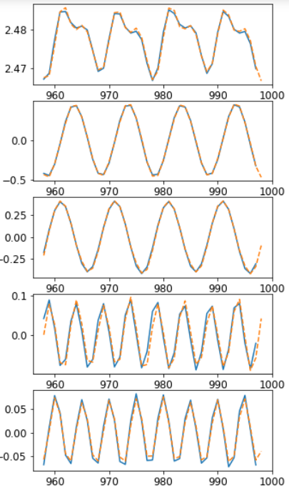

# July 7

### Archives

1. Make DCGAN work.
2. Continue to train with MLP.

DCGAN results:

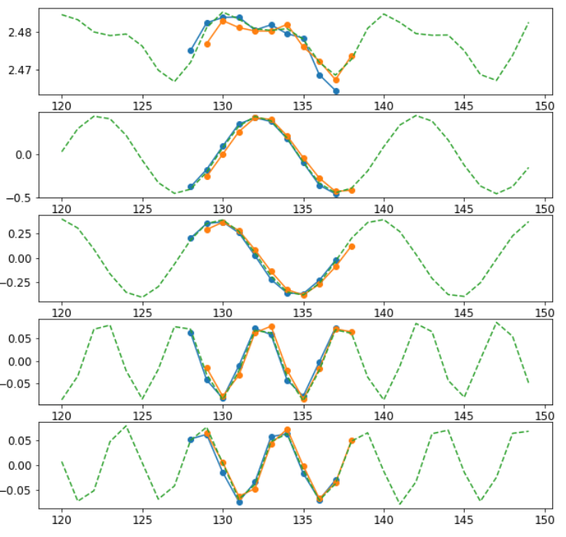

# July 14

### Archives

1. Understand PredGAN and use it to predict with DCGAN trained.
2. Finished training with MLP.

PredGAN results:

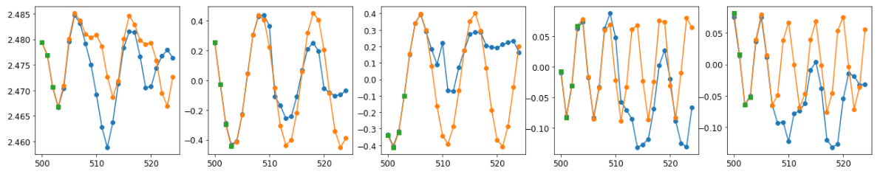

With deriv:

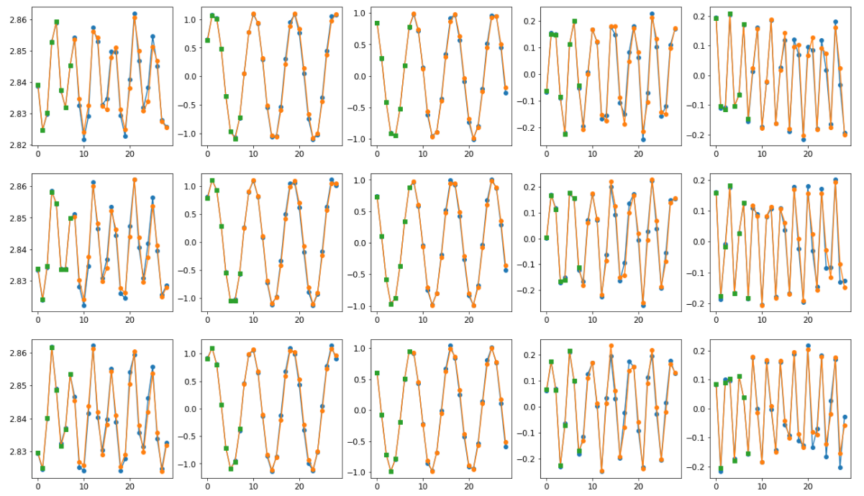

# July 21

### Archives

1. Applied 2-order time derivative method to MLP.
2. Applied time derivative method to DCGAN.
3. Figured out why the multiple-point prediction performed not well.

GAN training log:

1. Training set

Change to newFPC

2. Network structure

Why should the output graph be consistent with the input graph? Does changing the convolution kernel have any effect? Do you need to keep it consistent?

3. Training process

Understand the code, do you need to change it?

4. Model storage

5. Noise prediction results

Is it random? How to determine whether the forecast is accurate? GAN return problem?

6. Weight

What should the singular matrix be?

7. Single-step prediction results

How does the Error part appear?

8. Multi-step prediction results

Why is the effect poor? How to improve?

# July 28

### Archives

1. Do optimization to PredGAN architecture.
2. Do post-processing with DCGAN results and visualization.

The performance was enhanced a lot. Mainly by changing the convolution kernel size from (5, 5) to (3, 3). Small kernels help to get detailed features.

Besides, by changing the tf.keras.layers.Conv2D padding parameter from valid to same also helps. Because the valid mode would drop out the last few columns and rows which contains important information.

Since our input matrices are not real-life pictures but time series data, all of the matrix should be scanned.

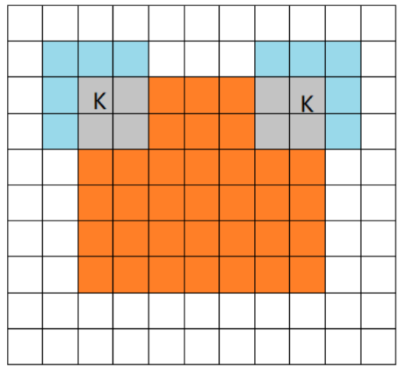

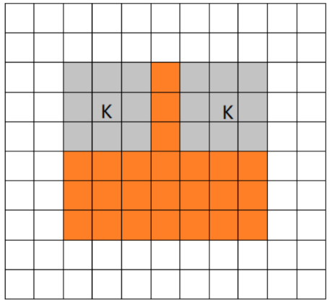

# Aug 4

### Archives

1. Subtract the mean before adding pod.
2. Using more derivatives (3, 4, 5, 6).

Seems that subtract the mean before adding pod has no help.

Changing singular values from old to new.

Besides, I’ve also changed the output mode. When using 3-order time derivs, the final results can create a full-time prediction.

# Aug 11-27

### Archives

1. Finished parameter optimization with wandb.
2. Applied AAE.
3. Write final report.

In these weeks, please directly see final report for analysis of results, comparison between models and conclusions.